Colorado Faculty Advisory Council (CFAC)
April 10, 2026, 9:00 am – 12:00 pm
Colorado Department of Higher Education
Hybrid Meeting
CU Denver Business School
1475 Lawrence Street, Room 4500
Denver, CO 80202
Join Zoom CFAC Meeting
Meeting ID: 740 783 2186
Passcode: CFAC

CFAC AGENDA
- GREETINGS (Welcome – Melinda Piket-May and Attendance Christina Carrillo)
(9:00 – 9:05 am)
- ADOPTION OF LAST MEETING’S MINUTES
(9:05 – 9:10 am) [See attached: CFAC Meeting Minutes 2.13.26]
- DISCUSSION/ACTION ITEMS
  - Vote on new CFAC chair and vice chair
  - CCHE - RECENT ACTIVITY (Wayne Artis) (9:10 am – 9:25 am)
  - GEC - RECENT ACTIVITY (Wayne Artis) (9:25 am – 9:45 am)
- DHE UPDATES (Brad Griffith and Christina Carrillo) (9:45 am – 11:00 am)
  - Preview of Reduced-Credit Bachelor’s degree faculty survey – Brad Griffith
  - CDHE Emerging Priorities – Brad Griffith
  - Legislative Updates – Brad Griffith
- CONTINUED DISCUSSION: (All) (11:50 am – 12:00 pm)
  - COLLEGE REPORTS (All) (11:00 am – 11:50 am)
  - CFAC topics for next meeting (11:50 am -12:00 pm)
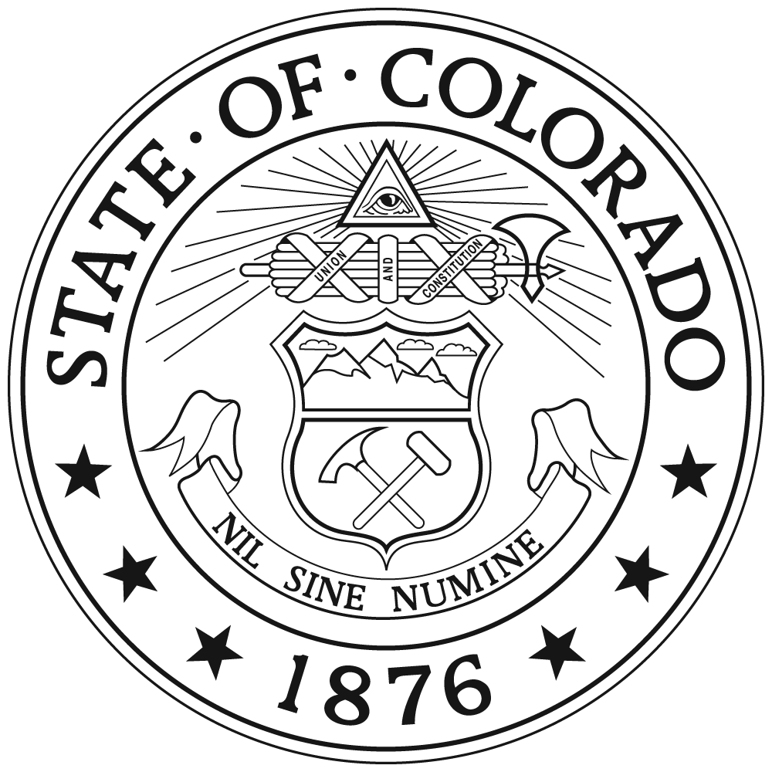
- ADJOURN (12:00 pm)

