Colorado Faculty Advisory Council (CFAC)
February 13, 2026, 9:00 am – 12:00 pm
Colorado Department of Higher Education
Remote Only
Join Zoom CFAC Meeting
Meeting ID: 934 0903 9717
Passcode: CFAC

CFAC AGENDA – NOTES
- GREETINGS (Welcome – Melinda Piket-May and Attendance Christina Carrillo) (9:00 – 9:05 am)
In attendance: Melinda Piket-May (CU Boulder); John Kinsey (FRCC); Jeffrey Reed (OC); David Fontenot (MSU Denver); Christine Noel (CMU); Ellie Camann (RRCC); Brian Lewton (NJC); Jess Gagliardi (ASU); Debbie Ficken (CNCC); Alastair Norcross (CU Boulder); Wayne Artis (PPSC); Kelly O’Dell (CCA); Travis Parkhurst (PCC); Gisella Bassani (CU Denver); Cedar Welker (UNC); Erica Henningsen (ACC); Diana White (CU Faculty Council); Joseph Horan (CSM); Christina Carrillo (CDHE); Carl Einhaus (CDHE); Brad Griffith (CDHE); JB Holston (CDHE)
- DHE UPDATES (9:05 am – 9:30 am)
  - Introduction of JB Holston, new CDHE Executive Director (9:00 am – 9:30 am)
JB Holston was introduced as the new Executive Director of the Colorado Department of Higher Education (CDHE). He shared that his priorities for the year are centered on two primary pillars: operational excellence and thought leadership.
Executive Director Holston noted that the current year is expected to be a transition year for the Department, as forthcoming legislation is anticipated to propose the consolidation of postsecondary education and workforce readiness under a single state agency.
Faculty members asked questions regarding his vision for CDHE in the context of the proposed legislation. Executive Director Holston indicated that many specifics related to the transition have not yet been determined and will be guided by the legislation itself. He noted that the bill is expected to establish a Transition Advisory Committee (TAC), which will play a central role in shaping transition planning and implementation.
- ADOPTION OF LAST MEETING’S MINUTES (9:30 am – 9:35 am)
[See attached: CFAC November 14, 2025 NOTES.docx]
Jess Gagliardi motioned to approve the meeting minutes from November.
Gisella Bassani seconded the motion.
No objections were made – meeting minutes approved.
- DISCUSSION/ACTION ITEMS
  - CCHE – recent activity (Wayne Artis) (9:35 am – 9:50 am)
Wayne provided a report on recent activity from the Colorado Commission on Higher Education (CCHE). He noted that the Commission has been highly active and is seeking to assert a more prominent role in policy and oversight matters.
He also informed the group that he will continue to share the Department’s daily news clips with faculty. Additionally, he provided brief remarks regarding the Executive Director transition at CDHE.
Lastly, Wayne provided an update on the work of the CCHE Transfer Subcommittee. It was noted that while the subcommittee currently includes a two-year faculty representative, there may be value in also adding a four-year faculty member to represent both sending and receiving institutional perspectives. The group nominated Joe Horan, faculty member at the Colorado School of Mines, to serve as the four-year faculty representative. Department staff will bring this recommendation to the Commissioners for consideration and approval.
  - GEC - recent activity (Wayne Artis- Inst rep for PPSC) (9:50 am – 10:00 am)
Wayne provided an update on recent General Education Council (GE Council) activity. He noted that Department staff have significantly improved guidance related to GT Pathways course review, including the development of a GT Pathways Course Review Checklist that clearly advises Council members on how to evaluate sample syllabi for new course proposals.
Wayne also reported that transfer reform continues to require substantial Council time, particularly as members review GT Pathways waiver requests for Bachelor of Applied Science (BAS) degrees. Discussion included concerns about how the absence of full GT Pathways requirements may impact transfer students and students who intend to pursue graduate study.
  - Election of Vice-Chair; Candidate: Jess Gagliardi, Adams State (10:00 am – 10:05 am)
Melinda informed faculty members that the current Vice-Chair, Mendy Smith, is stepping down as the chair of the Faculty Council for Colorado State University (CSU) as she will now be serving in the role of Vice Provost for Faculty Affairs. Jess Gagliardi has agreed to serve the remainder of Mendy’s term. No objections were raised, and two abstentions were noted.
Melinda also noted that her term as Chair will expire this year, and that at the April meeting the group will be asked to vote on a new Chair and Vice-Chair.
  - COLLEGE REPORTS (All) (10:05 am – 10:50 am)
- DHE UPDATES (10:50 am – 11:50 am)
  - New reduced credit bachelor’s degree - Brad Griffith, CDHE
Brad presented an overview of the Reduced-Credit Bachelor’s Degrees Survey and National Landscape Report, including background on accreditation flexibility under the Higher Learning Commission (HLC) and current statutory constraints in Colorado requiring 120 credits for bachelor’s degrees. The presentation summarized results from a statewide institutional survey, which was deployed to Academic Council members, highlighting varied levels of support for reduced-credit bachelor’s degrees, with many institutions open in principle if strong safeguards are established. Key themes included workforce alignment, cost and time-to-degree considerations, and concerns related to transfer, graduate school preparation, licensure, student confusion, and academic rigor.
Staff also reviewed emerging policy approaches from other states, common guardrails used nationally, and possible models Colorado could consider, including pilot-based frameworks with defined limitations and disclosure requirements. Emphasis was placed on the need for clear credential labeling, strong student disclosures, alignment with transfer pathways, and careful consideration of unintended consequences for students.
Faculty engaged actively throughout the presentation and asked several substantive questions. Discussion included potential impacts of reduced-credit bachelor’s degrees on students pursuing opportunities outside the United States, including how such degrees may be perceived internationally. Department staff indicated they will conduct additional research on this topic.
Faculty expressed interest in being included in a future survey focused on faculty perspectives and the academic implications of reduced-credit bachelor’s degrees. Department staff will work on developing a faculty-facing version of the survey that was deployed to Academic Council members.
  - Improving Statewide Transfer - Brad Griffith and Christina Carrillo, CDHE
Brad and Christina provided an overview of a new “Improving Statewide Transfer” webpage developed by CDHE. Staff also encouraged faculty members to attend meetings of the Colorado Commission on Higher Education (CCHE), noting that all CCHE meetings are open to the public.
  - Legislative Update – Brad Griffith and Christina Carrillo, CDHE
Brad demonstrated how faculty can locate higher-education–related bills on the state legislative website and reviewed how to navigate and interpret the information presented on individual bill webpages.
- CONTINUED OPEN DISCUSSION (All) (11:50 am – 12:00 pm)
    - Topics for next meeting?
Faculty members decided to meet in person for the April meeting. Melinda will work to secure space in downtown Denver and provide additional details closer to the meeting date.
A request was made to review the group’s bylaws. John Kinsey volunteered to assist Melinda with this task.
    - Trump Administration on Impacts Higher Ed
    - Mutual Defense Compact
    - National Council of Faculty Senates
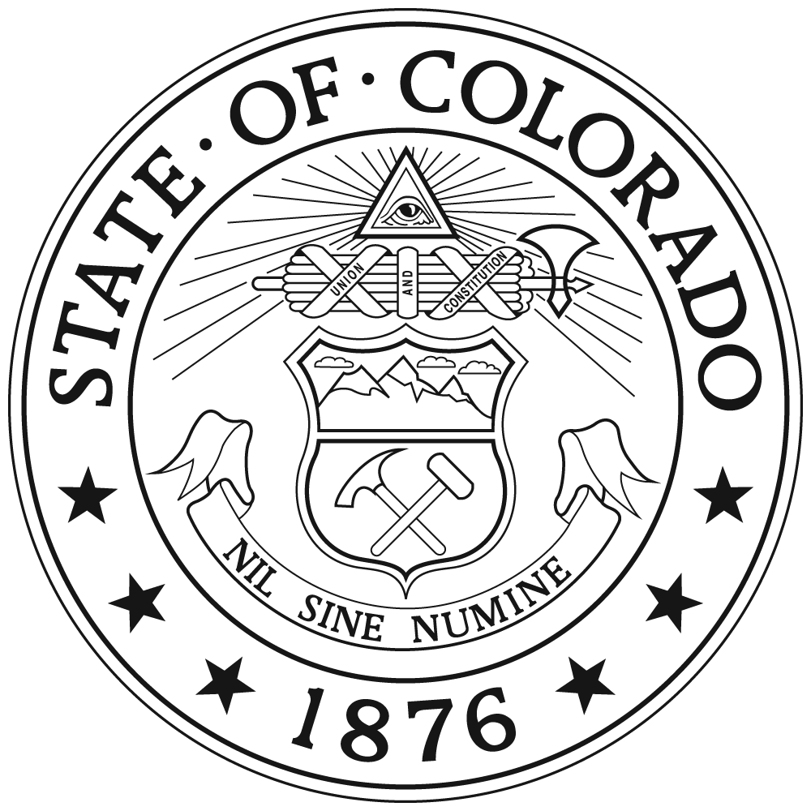
- ADJOURN (12:00 pm)

